**Assignment 1 Conclusions**

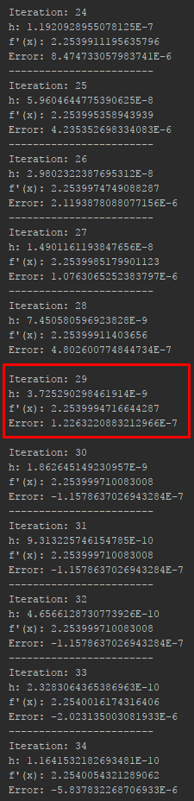Based on the output from the designed program, it can be said that up to a certain *h*-value the approximated derivative approaches the true answer. As shown in the figure below, as *h* gets closer and closer to the value 1.52587890625E-5, the approximated derivative converges to the true derivative.

At iteration 29, the approximated derivative is 2.2539994716644287. This is within 1.2263220883212966E-7 of the true derivative (2.2539995942966376896). However, after iteration 29, the approximation appears to diverge from the true answer, begins to increase, and the error becomes negative.

Also, after iteration 29, the results become more varied and random unlike the previous iterations where there was a noticeable pattern to the numbers being produced.